Jenkins 103

-> Creating developer role based access to Jenkins server

Pre-requiste:

Create a new project with name `credit-payment` in jenkins (see the previous notes)

Steps:

1. Start your jenkins server via `docker-compose up` in terminal
2. Go to `manage jenkins` and then click on `avaliable plugins`
3. Search for `Role-based Authorization Strategy Version` plugin and install in your jenkins server
4. Click on `Install without restart` and continue with installation.
5. Now, after installation, go to `manage jenkins` and click on `security`
6. Check the `authorization` drop down and select `Role-Based Strategy`. Click on `Save`.
7. After this, again go to `manage jenkins` and click on `Manage and Assign Roles`.
8. Under Global Roles, for `Role to add` tab, enter `Dev-user` and click on Add and give this user Overall `Read` permission. (By this, we provide global read access to this user)
9. Under Item roles, for `Role to add` tab, enter `Credit projects` and then on `Pattern` enter `credit-.*` and click on Add. Then give the user access appropriately.

Screen Shot:

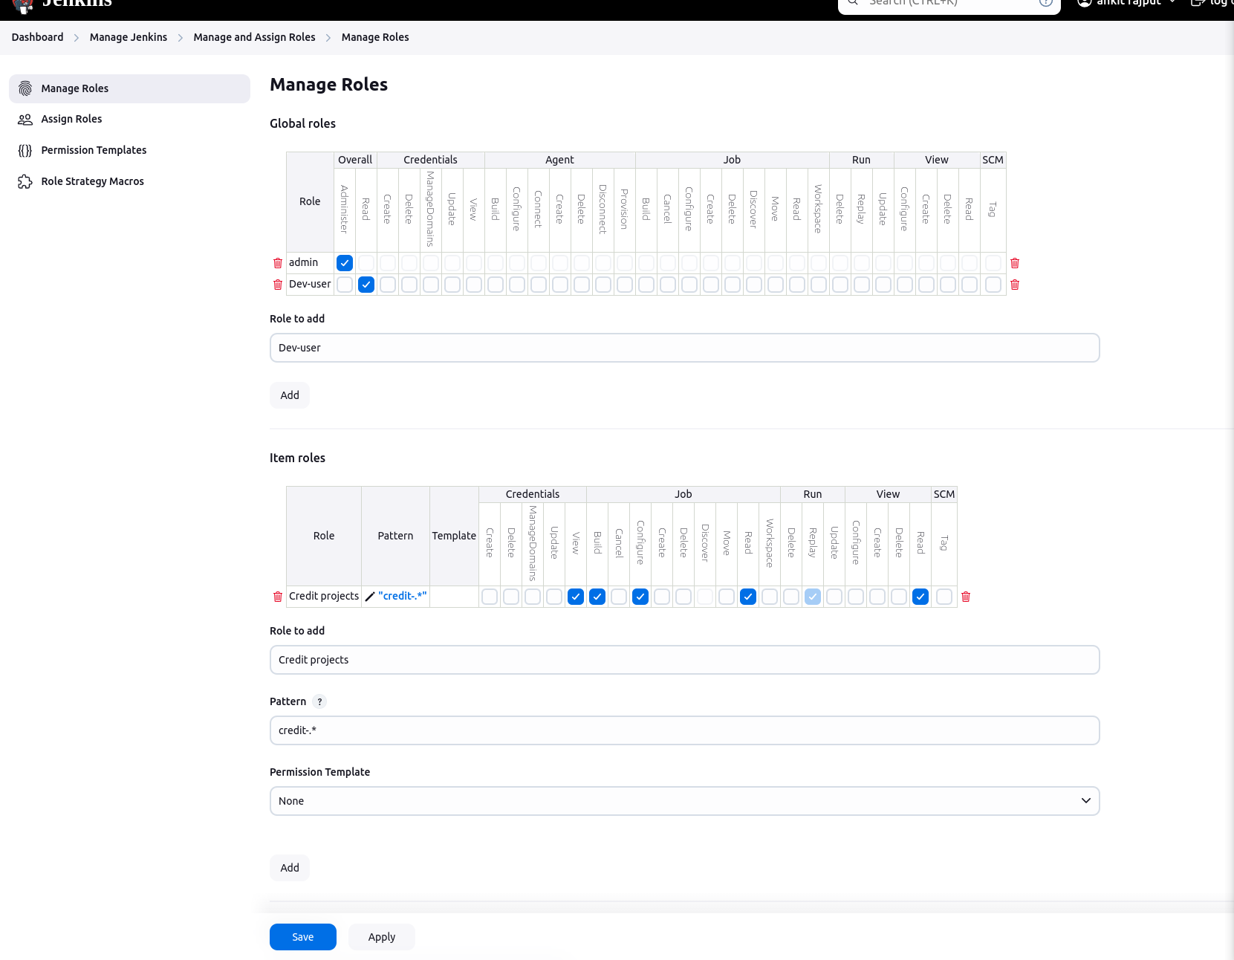

1. Finally, click on save, to complete the role creation step.
2. Now, let’s create a user and assign him this created role.
3. Go to `manage jenkins` and click on `Users`.
4. Click on `Create User` and enter the details appropriately. Finally, click on `Create User`.
5. Now, go to `manage jenkins` and click on ` Manage And Assign Roles` and then go to `Assign Roles`.
6. Under `Global roles` click on `Add User` and enter the Id of created user, then select `Dev-user` role.
7. Under `Item roles` click on `Add User` and enter the Id of created user, then select `Credit projects` role.

Screen shot:

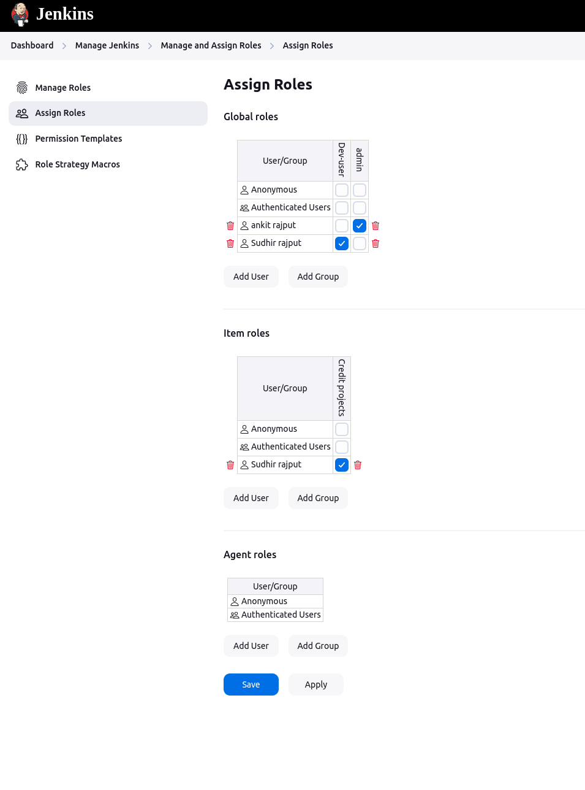

1. Save the page and log out.
2. Login with the created user credentials and you will only see and be able to work with `Credit projects`.

=> Way to configure the Email notification in Jenkins

Steps:

1. Go to `manage jenkins` and check if `[Mailer Plugi](https://plugins.jenkins.io/mailer)n` is installed (mostly it will be) if not, then go ahead and install this plugin.
2. Now, go to `manage jenkins` and then go to `System` and go to `E-mail Notification`.
3. Enter these details and create an app password via your gmail account

Youtube video: https://www.youtube.com/watch?v=TqiBFlU3ACU

Screenshot:

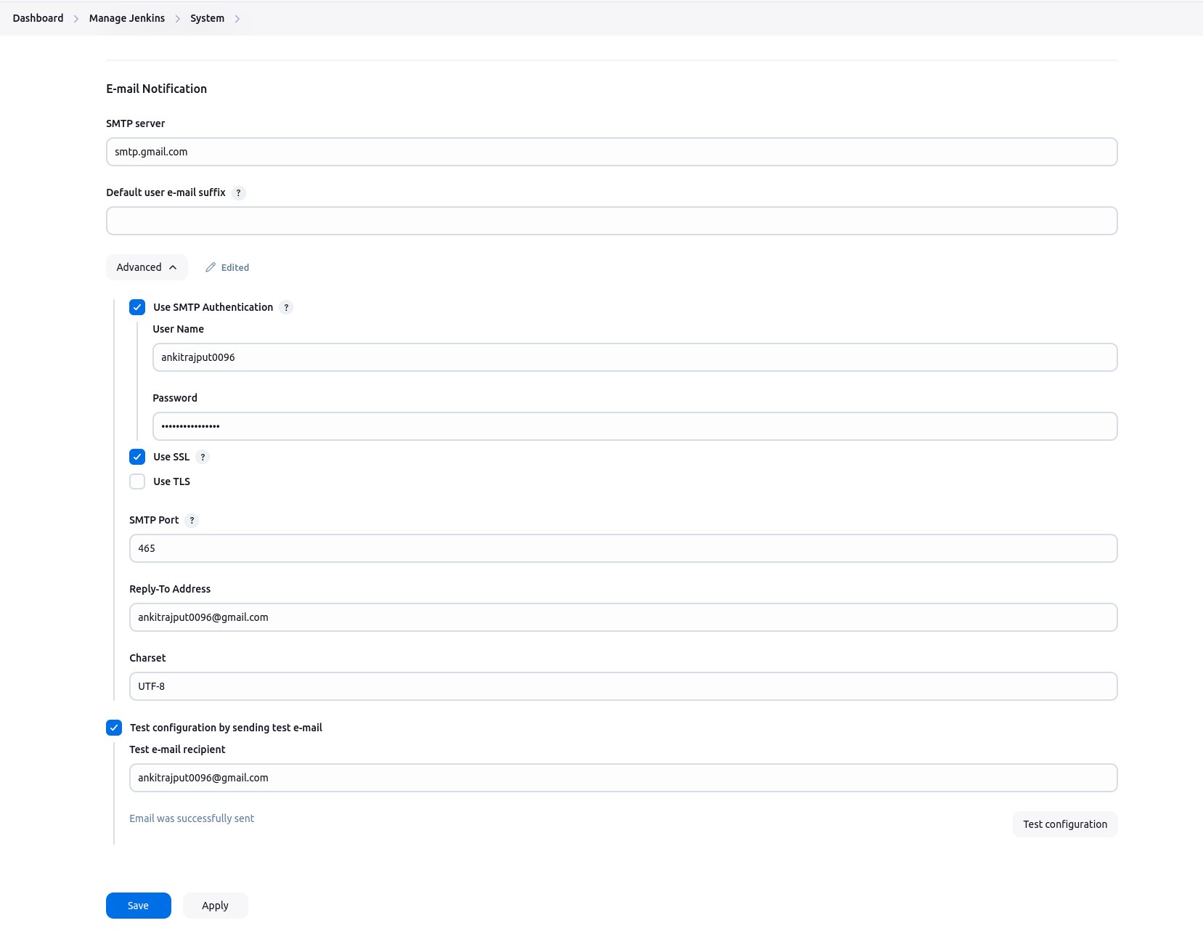

(NOTE: here, Password is newly created App password)

1. Now, your email notification is configured.
2. Finally, integrate email notification to jenkins job
3. Open any existing jenkins job and click on `Configure` job
4. Go to the `Post-build Actions` section and select `E-mail Notification` action.
5. Now, enter the details and save the settings.
6. Your email notification is now successfully integrated.
7. To test this email notification, again go to the `configure` job and update the job in such a manner that it fails and then build the job.
8. Once, the job fails and email will be triggered to registered email id.